荷兰代夫特科技大学

POWER CONVERSION

Electric Power Processing (EWI); prof. Ferreira

 | EMC in power electronic converters
Researcher | ???
Supervision in China | ??
Supervision in The Netherlands | Prof.dr. J.A. Ferreira
Short description | China does most of the power electronics production in the world. A difficult problem in the design of power electronic converters is electromagnetic compatibility (EMC). The switch mode operation of power transistors is known to be a major source electromagnetic interference. The requirements of electromagnetic compatibility (EMC) in, for example the automotive industry, is becoming more and more stringent, to avoid interference with sensitive electronic devices.  Traditional EMC remedies using heavy passive components or shielding add to the cost and is counterproductive to the miniaturization of power supplies. The project is about finding better solutions and design methods to reduce EMI and to develop based on the expertise and knowledge of the TUDelft on the application of new technologies and system integration.

Title | New Generation Wind Turbine Generators
Researcher | ???
Supervision in China | ??
Supervision in The Netherlands | Prof.dr. J.A. Ferreira
Short description | Accompanied with the fast economic growth, China faces continuous growth of electric power demand. It is estimated that the electric power demand of China will increase about 260% from 2000 to 2030. Renewable energy source can help to avoid future energy crisis, limit pollution and protect the environment. The continuous economic growth of China depends on the utilization of sustainable energy source. Among all the sustainable energy sources, wind power is the most mature and economic efficient technology. China has large amount of wind power potential, which is estimated between 160GW and 250GW. According to the "Eleventh-five" national development plan made by China government, the wind energy installation capacity in China is should grow to be 5000 MW until 2010 year.  TUDelft covers the full research fields of wind energy, from blade design to wind power integration. The Chinese company Goldwind has approached the TUDelft to collaborate in wind energy.  This project is about the power electronic converter and electromechanical generator design of the next generation of wind turbines. The Electrical Power Processing group of TUDelft is doing research on a 10MW directly driven wind turbine, and the research project of the PhD will be part of this activity.

WIND ENERGY /
ELECTRICITY DISTRIBUTION

Title | Integration of large scale wind farms in the grid
Researcher | ???
Supervision in China | ??
Supervision in The Netherlands | Prof.ir. W. Kling
Short description | Accompanied with the fast economic growth, China faces continuous growth of electric power demand. It is estimated that the electric power demand of China will increase about 260% from 2000 to 2030. Renewable energy source can help to avoid future energy crisis, limit pollution and protect the environment. The continuous economic growth of China depends on the utilization of sustainable energy source. Among all the sustainable energy sources, wind power is the most mature and economic efficient technology. China has large amount of wind power potential, which is estimated between 160GW and 250GW. According to the "Eleventh-five" national development plan made by China government, the wind energy installation capacity in China is should grow to be 5000 MW until 2010 year.  TUDelft covers the full research fields of wind energy, from blade design to wind power integration. The Chinese company Goldwind has approached the TUDelft to collaborate in wind energy.  The High Voltage Components and Power Systems group of TUDelft has a research program on the integration of wind farms in the electrical grid. This project will focus on small signal stability en problems related to reduced damping in the grid when wind energy is integrated on a large scale.

Five PhD proposals in Wind Energy topics

1. System Identification (1 PhD)

The current trend in the wind energy is to speed up the development and installation time of wind turbines. Every wind turbine and the conditions that they are facing are different and even changing with time. Nowadays, controllers are designed and tuned using aeroelastic simulations, and subsequently fine tuned during the prototype and 0-series phase. The fine tuning on-site is necessary due to differences between models and reality, and in some cases due to site-specific problems that may arise.
In order to automate the time-consuming tuning process closed loop system identification can be applied. Such techniques can yield accurate linear and/ non-linear models based on experiments performed on a real wind turbine. Such experiments may account for site-specific effects and even degradation effects of the wind turbine when they are repeated over time. With the information obtained from the system identification step the existing controllers can be updated in an automated procedure and we circumvent the time-consuming tuning of the feedback controllers.

The project objectives can be realized when suitable tools for experimental derivation of accurate models (system identification) have become available. In four tasks, the underlying methods are developed and implemented in preliminary tool form. Task 1 provides the data from which the system identification needs can be derived (benchmark). This concerns the turbine properties, control functionality and equipment, and specific behavioral aspects. Task 2 focuses on the actual development of the system identification methods from the needs that will be derived from the benchmark data. It is foreseen that different classes of methods will apply, depending on the related identification goal, which may concern structural dynamics, sensoring and actuation, wake-blade interaction or (unsteady) aero- or hydrodynamics. In Task 3, the controller parameterization will be coupled to system identification. Three types of identification based control will be addressed, viz. (i) use of offline (in-advance) identified model properties during control design, (ii); on-line matching the control parameters to slow varying turbine behavior (adaptive), and (iii) on-line fast tracking of control parameters to highly non-linear behavior (LPV). The developments in Tasks 2 and 3 will be (mainly) based upon simulation results from the benchmark data of Task 1. The developed methods will be verified and finalized in Task 4, based on true experimental data. In addition, the gained knowledge will be fed back to (guidelines for) analytic model improvement.

2. Rotor aerodynamics (2 PhD’s)

Wind Turbine Wakes
Because of the increasing size of wind farms, wake losses have and will become more important over the years. But to date wind farm design and wake control, aimed at minimising wake effects, are hampered by poor state-of-the-art knowledge: due to the complexity of the flow/structure interactions it is hard to develop analytical or numerical models. Full-scale experiments in the first generation of large wind farms have limited value because of poor meteorological measurements and uncertainties due to the stochastic nature of wind. In addition there are (legal) risks associated with control adaptations in real wind turbines. Wind tunnel experiments with model wind farms, on the other hand, do not have these drawbacks but have a poor representation of the wakes. As to experiments, and that is what is proposed here, the best of both worlds is to perform experiments in a small-scale wind farm. In parallel wind farm design and wake control modelling will be improved upon. This small scale wind farm is operated by ECN, the Dutch Energy Research Foundation. The proposed project is in close cooperation with ECN. ECN will be responsible for the measurements, and for analyzing and modelling of the far field of the wake. Within Duwind many experiments in wind tunnels on the near wake properties have been done. This expertise will be used to develop a model for the intermediate wake, which links the near- and far wake aerodynamic models.
The near wake models comprise a detailed description over a distance of typically half the diameter in the wake. Using a vortex restructuring algorithm together with a vortex decay model, both validated and verified with earlier wind tunnel experiments in uniform and yawed flow. This wake model will be extended to distances of typically 2 to 4 diameters behind the rotor, resulting in a detailed flow structure description that can de taken as input for Ainsly and ECN type far wake models.

Rotor Aerodynamics:
The availability of high quality measurements is considered to be the most important pre-requisite to overcome the uncertainties in wind turbine aerodynamics. Such measurements have recently become available within the EU project Mexico. In this project a large database has been created of detailed aerodynamic measurements on a representative wind turbine model, which was placed in the large DNW wind tunnel. This includes the measurement of pressure distributions around the blade and the measurement of the flow field around the rotor using PIV (Particle Image Velocimetry). The database is still in a rather rudimentary form and only limited analyses have been carried out. It is foreseen that the data will serve as a benchmark for aerodynamic analysis for the years to come. Most wind energy research institutions prepare an analysis programme to the analyze the data, and to validate the aerodynamic codes developed at the respective institutes. In this proposed project, Duwind will contribute to this (international) programme, focusing on the vortical structure of the rotor (bound vorticity) and near wake (free vorticity). The tools for analyzing this range from blade-element momentum methods, vortex lattice methods to CFD methods. It is expected that the project will deepen the knowledge of the unsteady aspects of aerofoil- and wake aerodynamics, and will result in improvements in design codes used by industry.

3. Design, build and test of a ‘smart structure’ rotor (2 PhD’s)

The loads and dynamic behaviour of modern wind turbine blades are controllable only by changing the pitch angle of the blade, collectively (all 3 blades simultaneously) or individual. With the increasing size of the turbines, the need for a more detailed control becomes apparent. The ongoing research programme for the next generation of blades aims to develop blades with embedded, spanwise-distributed aerodynamic control devices like trailing edge flaps. Using these devices, the loads should become controllable at any azimuthal position and at several spanwise positions, leading to a significant reduction of the blade load fatigue damage. This research requires an intensive cooperation between aerodynamicists, control experts, material and construction experts, and sensor/actuator experts. The embedding of the aerodynamic devices in the blade structure asks for a change in blade material and blade construction. This is greatly facilitated by using thermoplastic composite material instead of the current thermoset material, since this makes efficient use of spars and ribs possible. The research so far has concentrated on the analysis and design, supported by wind tunnel experiments. The next step is to design, build and test a ‘smart structure’ rotor in real atmospheric conditions.

Since Duwind has a close cooperation with ECN, the Dutch Energy Research Foundation, one of the wind turbines in the ‘scaled wind farm’ of ECN will be made available for this. This small wind farm consists of several wind turbines of 7 m diameter, having variable speed operation and full span pitch control. The rotor to be designed, built and tested will be mounted at one of these turbines. The measurements will be performed by experts from ECN, in close cooperation with Duwind.

The objective of the two proposed PhD projects is to take the research from the previous phase, wind tunnel tested feasibility of the concept, to the proof of concept by a test in real atmospheric conditions, including the design of the rotor, assistance in manufacturing it at the Aerospace Faculty, preparation and analysis of the experiment, and analysis of the possibilities for further upscaling. One PhD researcher will focus on the performance part of the problem, the second one on the thermoplastic material and construction part.

SOLAR CELLS

Dimes (EWI); Dr. Miro Zeman

TUD PhD research projects in China 2007

Author and contact person: Dr. Miro Zeman
Delft University of Technology-Dimes
Laboratory of Electronic Components, Technology and Materials
Research area: Solar cells

Research project 1:
2-D modelling of thin-film solar cells

Introduction: The Solar Cells group at Delft University of Technology has developed a 1-dimensional (1-D) device simulator ASA (Advanced Semiconductor Analysis). This simulation program is pre-eminently suitable for studying thin-film solar cells. The ASA program integrates both optical and electrical modelling and includes most advanced physical and material models for both crystalline and amorphous semiconductors. The program is used all over the world by the leading research groups in the field of thin-film solar cells. The ASA program can successfully carry out the analysis and predict the performance limits of current thin-film silicon solar cells. However, to push the efficiency of thin-film solar cells towards 20% it is required to investigate 2-D effects of light propagation and spatial variation of electric transport. The 2-D simulations can result in breakthroughs that will point out the way for experimental work to develop 2-D or 3-D structures in order to deliberately improve the light management in the solar cells and improve collection of photo-generated charge carriers.

Description: The ASA program will be extended into 2-D device simulator. Device geometrical description and extension of the solution of a set of semiconductor equations into 2-D will be executed. Simulations of the effect of 2-D structures, such as 2-D photonic crystals, on the performance of solar cells will be carried out.

Challenges: A model for light propagation from 2-D geometrical structures has to be developed and implemented into the program. The developed program modules have to be step by step tested and calibrated using 2-d experimental structures.

Requirements: A student should have a good background in semiconductor device physics and modelling skills.

Research project 2:
Development of thin-film nano-crystalline silicon solar cells

Introduction: Hydrogenated microcrystalline silicon (μc-Si:H) deposited by low-temperature PECVD technique is a promising candidate for the low band-gap material in multi-junction a-Si:H based solar cells. The University of Neuchâtel introduced a micromorph tandem solar cell in 1994, which comprised an amorphous silicon top cell and a μc-Si:H bottom cell. The promising potential of the micromorph cell concept was soon demonstrated by the fabrication of micromorph tandem and triple solar cells with stabilized efficiencies in the range of 11 to 12%, and Kaneka Corporation started the development of micromorph module production technology.
The microcrystalline silicon films are a mixture of crystalline and amorphous silicon phase that varies as a function of thickness of the film. The size of crystallites is in the range of nanometers and therefore this material has been recently referred to as nano-crystalline silicon (nc-Si:H). These films are deposited from mixtures of silane and hydrogen using plasma-enhanced chemical vapor deposition (PECVD) techniques. A general feature using these deposition conditions is an inhomogeneous growth in which the fraction of amorphous and crystalline phase changes. There is a general consensus that the best nc-Si:H material for use in solar cells is at the transition from a mixed amorphous and crystalline phase to fully crystalline phase. However, the optimal nc-Si:H material regarding the fraction of crystalline part in the films has still to be identified. At the same time, the deposition conditions for a homogeneous growth of nc-Si:H films with a particular crystalline fraction have to be determined.

Description: Deposition conditions of nc-Si:H films will varied and the structural and opto-electronic properties of resulting films will be characterized. Also the deposition conditions for ultra-thin doped nc-Si:H layers (20 to 30 nm thick) will be optimized. Solar cells with nc-Si:H absorber layers will be fabricated and characterized.

Challenges: Determine deposition conditions for growth of uniform films regarding the crystalline fraction in the nc-Si:H films. Determine the optimal crystalline fraction in the nc-Si:H films for obtaining the highest performance of solar cells with the nc-Si:H absorber layer. Optimize the doped and buffer layers for maximal solar cell performance.

Requirements: A student should have a good background in semiconductor device physics and some experience with deposition and characterization of thin semiconductor films.
Research project 3:
2-D photonic crystals for efficient light management in thin-film silicon solar cells

Introduction: For obtaining high conversion efficiency of thin-film silicon solar cells the proper light management inside the solar cell structures is of great importance. At present the light management is accomplished by light-trapping techniques that are based on the introduction of surface-textured substrates and the use of special layers called back reflectors. These light trapping techniques have been first introduced in thin-film amorphous silicon (a-Si:H) solar cells in the 1980s and resulted in an increase of short-circuit current density of 3 to 5 mA/cm² in comparison to solar cells deposited on flat substrates and without the back reflector. The surface texture of both front glass/TCO (transparent conductive oxide) superstrates and back metal-reflector substrates has been optimized by several groups, among others the Asahi Corp. in Japan, Research Center Julich in Germany, University of Neuchatel in Switzerland, United Solar company in USA. The aim of this research project is to investigate the effect of 2-D photonic crystals fabricated in thin silicon layers on light propagation inside TF Si solar cells.

Description: 2-D periodic structures can wavelength-selectively scatter and manipulate the propagation of light. A better understanding of the effects of light scattering and propagation using the 2-D photonic crystals is necessary for the development of improved light trapping schemes and implementation of these structures in solar cells. Relation between the geometrical features of 2-D structures formed in thin silicon layers and the light scattering properties will be investigated in this project.

Challenges: Formation of the 2-D photonic crystals in thin silicon layers using advanced lithographic approaches. A precise measurement of the scattering parameters of 2-D structures in the wavelength range from 200 to 1200 nm. The haze parameter will be determined using an advanced spectroscopic set-up with integrated integrating ball. The angular distribution function will be determined by Angular Resolved Spectroscopy for several wavelengths.

Requirements: A student should have a good background in physics and semiconductor device physics.

Opto-electronic Materials (TNW) – prof. Laurens Siebbeles

Projects "Towards the next generation of solar cells"

The PhD student or post-doc will be appointed in the Faculty of Applied Sciences (TNW) of Delft University of Technology (TU Delft), and will join the Opto-electronic Materials Section of the DelftChemTech Department (www.dct.tudelft.nl/om).
The high costs and limited efficiency of conventional solar cells, based on crystalline silicon, drives the worldwide search for new solar cells that are cheap and provide high efficiency. The ultimate solar cell is cheap and converts most of the incident solar energy into electrical
energy. New nano-structured materials have a great potential to realize this next generation of solar cells. Fundamental research into the dynamics of photo-excited states and charge carriers in relation to material structure will be carried out. Studies will focus on a) cheap
solar cells and b) highly efficient solar cells.Cheap and mechanically flexible solar cells. Materials include composite organic (conjugated polymer, fullerene) and hybrid
organic/inorganic (polymer or dye in combination with metaloxide) structures. Until now the highest power conversion efficiency achieved with an organic based solar cell is 5%. Challenges to enhance the efficiency include the development of new materials with improved absorption of the red part of the solar spectrum, enhanced charge separation efficiency per incident photon and improved charge transport properties.
Highly efficient solar cells. In a conventional solar cell based on a(bulk) semiconductor layer, photo-excited electrons and holes rapidly convert their excess energy (difference between photon energy and semiconductor band gap) into heat due to thermalization of the
charges by scattering with lattice phonons. It will be studied how this loss of electrical energy can be minimized by using inorganic nanoparticles as a light absorbing medium.

Job description
The research will focus on the fundamental understanding of processes involved in charge generation and transport in nanostructured materials with potential application in solar cells. The nature and dynamics of charge carriers and excitons will be studied using (ultrafast) time-resolved techniques. Charges and excitons will be produced using high-energy electron or laser pulses, ranging from the femtosecond to the nanosecond time-domain. Charges and excitons will be probed using optical detection and microwave or terahertz conductivity measurements. The candidate may become involved in theoretical studies of charge and energy transfer. The results of the research will contribute to the development of cheap and/or highly efficient solar cells.

FUEL CELLS

Section Energy Technology, (3mE; Aravind, P.V. [P.V.Aravind@TUDelft.NL])

Detailed modelling of flow, temperature and thermo-mechanical stress fields in a Solid Oxide Fuel Cell (SOFC) stack

Prepared by: Aravind PV and Nico Woudstra, Section Energy Technology, TU Delft
Date 09-10-2007

Background:

A Solid Oxide Fuel Cell (SOFC) is a device that electrochemically oxidises fuels to produce electricity. The potential produced by one fuel cell is quite small around 0.7-1.0 V, This means that to produce a useful voltage, many cells have to be connected in series to form a fuel cell stack.

In SOFC stack design the gas flow distribution plays an important role. This distribution should be uniform over all cells in the stack but also inside the individual cells. Inside the cell, the anode gas flow should be distributed uniformly because of its high conversion rate. A non-uniform distribution will result in lower performance and enhanced degradation of the cell. The cathode gas flow is needed for oxygen supply and cooling. The gas flow distribution over the complete stack influences the temperature profile and hence the thermo-mechanical stress fields in the components of the stack.

The Energy Technology section of the Delft University of Technology is now involved in a Dutch national initiative for designing a 20 kW SOFC stack with a specific contribution to the CFD modelling of fuel and coolant flows in the stack. This project is performed in close collaboration with the solid oxide fuel cell technology group at ECN. The proposed new PhD position is expected to augment the ongoing stack design activities at the section. The project will focus in particular on the interactions between the processes taking place in the cells (electrochemical and chemical reaction and fluid flows).

Electrochemical knowledge available in the literature as well as from the ongoing studies within the section will be used for detailed CFD modelling. The Energy Technology section has two different software tools available for fuel cell modelling and they will be used for the present study (the Fluent fuel cell module and COMSOL). COMSOL also can be used for modelling thermo-mechanical stresses. The new PhD student is expected to improve the stack model which is being developed at present with specific contributions to 1) use of electrochemistry and 2) thermo-mechanical stress modelling.

Objectives

- Evaluation of the advanced electrochemical models for SOFC applications and the use of the same for CFD modelling of an SOFC stack
- Detailed modelling of thermo-mechanical stresses in the stack.
- To study the dynamic performance of the fuel cell stack

Proposed activities:

- Evaluation of advanced electrochemical models for cell and stack models (literature study)
- Improve the existing cell and stack models by including detailed electrochemistry
- Detailed modelling of gas flow and temperature fields at cell and stack level
- Detailed modelling of thermo mechanical stresses in the stack components
- Propose recommendations for an improved design of the SOFC stack
Design the balance of plant components for the SOFC stack

Energy systems with intermediate temperature solid oxide fuel cells: Fuel oxidation on ITSOFC anodes and its influence on system performance

Prepared by: Aravind PV and Nico Woudstra, Section Energy Technology, TU Delft
Date 22-01-2007

Solid oxide fuel cells are emerging as a possible choice for future energy systems. However, the fact that they have to operate at very high temperatures requires expensive materials for their construction. This increases the cost of SOFC based energy systems. By dropping the operating temperature to below 800 ºC, the use of less expensive materials such as stainless steel for manifold, piping, heat exchangers, blowers, etc., can be achieved and the system is less prone to thermal degradation. However, inherently lower fuel oxidation kinetics at lower temperature may necessitate significant catalytic activity from the anodes. This in turn shall increase the influence of fuel-derived contaminants on SOFC performance. Such SOFCs, working between 600-800 ºC are often called as Intermediate Temperature Solid Oxide Fuel Cells or ITSOFCs.

Lower electrolyte thickness required for reducing electrolyte losses for such cells often lead to the development of anode-supported cell configurations. To evaluate the use of ITSOFCs with real life fuels, detailed understanding of the fuel oxidation on ITSOFC anodes is necessary. Knowledge of electrochemical fuel oxidation will in turn help to design and optimize the anodes for working with real life fuels and to develop macro-scale models for analyzing the performance of ITSOFC stacks. Realistic system parameters obtained from such studies also shall be used for development of thermodynamic concepts for high efficiency energy systems based on ITSOFCs such as ITSOFC- gas turbine systems.

Objectives

- To study the electrochemical fuel oxidation on intermediate temperature SOFC anodes and to arrive at suggestions for optimal anode micro structure
- To study the influence of various fuel gases on the performance of intermediate temperature SOFC anodes and complete cells
- To arrive at concepts for high efficiency ITSOFC- gas turbine systems using the information generated from the studies mentioned above.

Activities

- Preparation of SOFC anodes with varying micro structure (TUD-ECN)
- Impedance measurements on the anodes developed with various gas compositions and interpretation of the results (TUD-ECN)
- Preparation of complete cells using the developed anode (ECN).
- Testing of the cells with varying gas compositions representing various fuel compositions (TUD-ECN)
- Influence of contaminants such as H₂S on anode performance using impedance and I-V curve measurements with a special focus on possible sulfur intake on ceria based anodes at reducing conditions (TUD)
- Energy and exergy analysis of systems with ITSOFCs and gas turbines with hydrogen and natural gas with and without external reforming, resulting in a system conceptual design that enables comparison with alternative system options. Comparison of the thermodynamic performance of ITSOFC- gas turbine systems and high temperature SOFC- gas turbine systems (TUD)

Manpower requirement

TUD- PhD candidate 4 years

Additional financial requirement

Approximately 2 00 000 Euro for the purchase of the experimental set-up and fabrication of test cells.
NUCLEAR ENERGY

Radiation Radionuclides Reactors; Section Physics of Nuclear Reactors (TNW);
Dr. J.L. Kloosterman; Physics of Nuclear Reactors, Delft University of Technology
(www.janleenkloosterman.nl

Research on the Very High Temperature Reactor (VHTR)
(2 PhD projects)

The Very High Temperature gas-cooled Reactor (VHTR) is the most promising reactor design within the Generation-IV initiative. It produces heat at a high temperature of 1000 ⁰C, which enables one to apply the VHTR to the generation of electricity at high efficiency or to the production of hydrogen via thermo-chemical processes or hot electrolysis. Both PhD projects focus at the Chinese HTR-PM design and will be carried out in close cooperation with the INET of Tsinghua University in Bejing, China.

PhD Project 1
This research aims at a maximization of the power rating of the HTR-PM without increase of reactor vessel dimension. The PhD student will first focus on the HTR-10 to validate the calculation scheme with the models from INET and with experimental data. The next phase deals with the HTR-PM power increase to its maximum value. Focus will be on the power profile and temperature distribution in the core during normal operation with the aim to get a distribution as flat as possible. Especially the “edge” effect in the porosity of the pebble bed (the effect that along the reflector boundaries, the porosity of the bed is non-uniform) will be dealt with. Subsequently the temperature profile in the core during transients will be investigated to ensure that the limit of 1600 ⁰C will not be exceeded. The analyses will be done with an advanced neutronics code system coupled to thermal-hydraulics.

PhD Project 2
This PhD student will focus on the use of thorium in the HTR-PM. Thorium is abundantly present in the earth’s crust, enabling one to extract energy from a cheap and commonly available resource. Several fuel cycle scenarios will be considered, like thorium usage with enriched uranium (up to 20%) or with plutonium from other reactor types. Advanced fuel depletion and recycling studies will be performed using an in-house developed code system. The safety case of thorium usage in the HTR-PM will be investigated with a coupled neutronics and thermo-hydraulics code system. Besides the performance and safety case of a stand-alone thorium-fueled reactor, also the synergy of thorium-fueled HTRs with an existing reactor park can be investigated.

Both research projects will be carried at the section Physics of Nuclear Reactors (PNR) of the faculty of Applied Physics of TU-Delft, which is well-known for its research on innovative nuclear reactor designs. The research will be carried out in cooperation with the Institute of Nuclear and New Energy Technology (INET) of Tsinghua University in Bejing, China. For more information about the section, please visit www.rrr.tudelft.nl/pnr or contact Dr. J.L. Kloosterman ( j.l.kloosterman@tudelft.nl ).

Design of an inherently-safe Gas-cooled Fast Reactor (GFR)
(1 PhD project)

Dr. J.L. Kloosterman, Physics of Nuclear Reactors, Delft University of Technology; www.janleenkloosterman.nl

To improve the sustainability of the nuclear fuel cycle, nuclear reactors are needed that can extract much more energy from thorium and uranium than is possible with present-day reactors. To this end, fast neutron reactors are needed which are able to convert U-238 to Pu-239 or Th-232 to U-233. This way, about 100 times more energy can be extracted from uranium and thorium making nuclear energy a cheap and real sustainable energy source.

This PhD project focuses on the design of a Gas-cooled Fast Reactor (GFR); one of the six Generation-IV reactor designs. Due to the helium cooling, the neutron spectrum in this reactor is harder than in liquid-metal cooled reactors, facilitating a high breeding gain, but troubling the safety case of the reactor. Therefore this project focuses on the following research topics for the GFR:
- Inherently safe shut-down mechanisms to mitigate the consequences of reactivity induced accidents.
- Inherently safe decay heat removal systems to prevent core damage after a loss-of-cooling accident.
- Sustainable fuel cycle based on the uranium-plutonium fuel cycle or on the thorium-uranium cycle.

The research will be carried at the section Physics of Nuclear Reactors (PNR) of the faculty of Applied Physics of TU-Delft, which is well-known for its research on innovative nuclear reactor designs. The research will be carried out in cooperation with the other main labs and universities in Europe and the USA. For more information about the section, please visit www.rrr.tudelft.nl/pnr or contact Dr. J.L. Kloosterman ( j.l.kloosterman@tudelft.nl ).
Design of a small inherently-safe Nuclear Battery (1 or 2 PhD projects)

Dr. J.L. Kloosterman; Physics of Nuclear Reactors, Delft University of Technology
(www.janleenkloosterman.nl)

At present, about 1 billion people rely on nuclear energy for their electricity needs. In Europe, 35% of all electricity and 50% of base load capacity originates from nuclear. A growing momentum towards small-sized reactors and non-electric applications indicate that nuclear energy can serve other needs as well. Small inherently-safe nuclear reactors with a long-life core, called Nuclear Batteries, can generate energy for decades at a low and constant price without refueling. Examples of applications are:
- Electricity and heat production for industrial consumers.
- Electricity and/or heat production for isolated communities.
- Ship propulsion.
- Sub sea applications to enable the exploitation of oil/gas fields far off the coast.

The PhD student(s) will investigate the following topics:
- Optimization of the burnable poison distribution and enrichment zoning of a Nuclear Battery with a thermal neutron spectrum. In an inherently-safe reactor, the initial surplus reactivity needs to be compensated by passive means. The aim of this study is to get a reactivity swing as small as possible and for a period as long as possible. Advanced techniques will be developed to calculate the sensitivity of the results to the initial conditions.
- Research into the dynamic behavior of a Nuclear Battery coupled to an energy conversion system. The Nuclear Battery should adapt to the energy demand under all circumstances, which requires proper power feedback mechanisms. These can be provided by the fuel and coolant reactivity coefficients, and by inherently-safe reactivity feedback devices like Lithium Expansion Modules. The research into these options requires new tools to simulate the dynamic behavior of Nuclear Batteries. The results will be applied to a Nuclear Battery preferably cooled via natural circulation of the coolant. The reactor coolant could be liquid metal or a molten salt as envisaged within the Generation-IV initiative.

The research will be carried at the section Physics of Nuclear Reactors (PNR) of the faculty of Applied Physics of TU-Delft, which is well-known for its research on innovative nuclear reactor designs. The research will be carried out in cooperation with the other main labs and universities in Europe and the US. For more information about the section, please visit www.rrr.tudelft.nl/pnr or contact Dr. J.L. Kloosterman ( j.l.kloosterman@tudelft.nl ).
ENERGY SAVING: LOW WEAR COATINGS

Technische Materiaalkunde, 3ME, prof.dr. G.C.A.M. Janssen

Integrated low wear, low friction coating; Nanocrystalline base layer and DLC top layer.

Applicant:

prof.dr. G.C.A.M. Janssen
Technische Materiaalkunde, 3ME, TU Delft, Mekelweg 2, 2628 CD, Delft.
Telephone: 015 - 2781684/ 015 - 2782285
Fax: 015 - 2786730
E-mail : G.C.A.M.Janssen@tudelft.nl
Website : www.surfacesandinterfaces.3me.tudelft.nl

Key words: Low wear, low friction, drive-train, DLC, CrN, nanocrystalline coating, reactive sputter deposition.

1. Summary

High performance coating systems for application in car engines have to reduce the friction and thereby the fuel consumption and CO₂ emission. State of the art coating systems consist of a CrN base layer and a DLC top layer. The CrN layer provides the support for the low friction, but relatively soft DLC layer.
The present proposal is centered about improving the load bearing capacity of the CrN coating. The proposal includes manufacturing of the integrated coating system and testing. We propose to investigate the merit of various nanocrystalline modifications of the CrN coating for a load bearing layer. The goal is to improve the load bearing capacity of the CrN base layer and to unveil the mechanism by which this is achieved. Based on our experience with polycrystalline CrN we expect that the ion bombardment will play a crucial role in obtaining high quality nanocrystalline material.
Coating systems with increased load bearing capacity will allow for higher torque at the same design weigth or for lower weigth at the same design torque. Either way the fuel efficiency will increase and the CO₂ emission will decrease. Frictional losses in car engines are responsible for 1.8% of the CO₂ emission.
In order to guarantee the utilization of the results, the project will be performed in close cooperation with Ionbond, one of the world largest suppliers of coatings. Ionbond will deposit the DLC top layer and perform the industrial wear testst. Already after one year we will have first results on the integrated system. This very early testing of the integrated system is essential to warrant a transfer of the results to Ionbond. Only by incorporating the industrial feedback so early in the project can we hope to attain an industrial relevant result at the completion of the project.

2. Research group

The main part of the research will be performed in the Surfaces & Interfaces group at the TU Delft. This group consists of one full professor, two part time professors, an associate- and an assistant professor, three technicians, post-docs, PhD students and master students. The research in the “Low wear, low friction” project will be mainly performed by a PhD student. He/she will receive daily guidance from prof.dr. G.C.A.M. Janssen, support from the technicians, and some input from the post-docs and other PhD students.
At present no candidate has been selected.

3. Research plan

State of the art coating systems for appliation in engine and drivetrain systems both provide low friction and high wear resistance. These systems consist of a CrN base layer and a DLC (Diamond like carbon) top layer. The CrN layer is hard and wear resistant. It provides support for the somewhat softer DLC top layer. The DLC top layer provides the required low friction.
Both the CrN layer and the DLC layer have options for improvement. For the DLC coating the amount of incorporated hydrogen is the most likely candidate for improvement of the wear resistance. For the CrN coating the transfer from nowadays applied polycrystalline coatings to nano-crystalline coatings is a route worthwhile investigating.
The global division of work in this proposal is that TU Delft will work on the nanocrystalline base layer and that Ionbond will work on the DLC top layer and integration aspects. Ionbond will also reproduce the results obtained in Delft on the nanocrystalline base layer in order to warrant transfer.
The main idea for improvement of the CrN coating is the prevention of crack formation in that coating caused by mechanical loading of the coating system. Cracks do form in the coating once the deformation by mechanical loading leads to stress levels in the coating and hence an elastic energy density such that it is energetically more favourable to have a small irregularity grow out to form a crack than to retain the elastic energy. This energy balance is known by the name Griffith criterion. The Griffith criterion offers a number of options to prevent crack formation.

1. Minimize irregularities. One needs higher stress levels to have a small irregularity grow out to form a crack, than one needs for a larger irregularrity. This approach has been used very succesfully in the application of glass fiber reinforced polyester. The irregularities on the glass fibers are in the nanometer range and the strenght of the fibers approaches the theoretical tensile strength. [1]

2. Pre-load the coating. By depositing the coating is such manner that the coating is under compressive stress one allows for a larger deformation of the coating before the critical stress for crack formation is reached. [2]

3. Lower the Young’s modulus of the coating. At the same deformation, the elastic energy density will be smaller. Young’s modulus is proportional to the second spatial derivative of the binding energy of the atoms constituting the coating. For typical hard coating materials the hardness is proportional to the magnitude of the binding energy. Therefore hardness and Young’s modulus are not independent variables. Still Leyland and Mathews have argued that one should optimize H/E in order to prevent crack formation [3]. This argument is based on the notion that H/E can be seen as the maximal elastic strain.

In 1999 Musil showed how to make nano-crystalline films by frustrating competitive grain growth. He demonstrated the principle by adding some copper during the growth of a CrN film. The resulting film was nano-crystalline due to the frustration of the outgrowth of CrN grains [4]. Since that date various reports on nanocrystalline films have been written, both by the mechanism proposed by Musil as well as by growing two incomensurable hard materials at the same time, see e.g. the paper by Patscheider [5]. It is almost impossible to judge the value of these reports for application since the starting point material, e.g. CrN is oftentimes not well enough defined. Matthews reports a dependence of hardness on composition [3]. A few years later we demonstated that the reported dependence of hardness on composition was in fact only a dependence of hardness on density. The more porous films were less hard [6]. The cause of his dependence was traced back to a composition dependent surface mobility. Once enough energy is supplied by an ion bombardment, the surface mobility becomes composition independent, hence the density and also the hardness no longer depend on composition. In 2005 Baker et al. published a paper on Cu-CrN nanocomposite coatings [7], in which the wear properties for various types of wear were investigated as function of the composition. From that paper it seems that nanocrystalline CrN outperforms polycrystalline CrN in various types of wear. Unfortunately from the results presented in [7] it is not possible to draw firm conclusions. The problem with the results may be the method of sample fabrication. The various compositions were attained by placing the samples at different distances from the two targets, Cu and Cr. The closer to a target the larger fraction of that metal in the film. In this way not only the composition changes, but also the distribution of arrival angles. We propose to deposit nanocrystalline films from two targets in an industrial deposition system. All samples will describe planetary motion through the deposition chamber. We will deposit coatings by simultaneous sputtering from two targets, a Cr target and a Cu or Cr/B or Cr/Si target.We will vary the composition by varying the power to the Cu, Cr/B, Cr/Si target while keeping the power to the Cr target constant.

In the present proposal we want to investigate the merit of a nanocrystalline CrN base layers for application in CrN-DLC coatings for drive train and engine applications. We want to investigate Cu-CrN, Si-CrN and B-CrN coatings. We will deposit these coatings by reactive sputter deposition in an industrial deposition tool, Hauzer HTC 750. We will characterize these coatings with respect to composition, crystal structure, microstructure, stress, stress gradients and roughness. In our recent work on polycrystalline CrN [6,8] we have demonstrated the dramatic influence of ion bombardment on density and hence mechanical properties of the coating. The imporance of a well managed ion bombardment for polycrystalline CrN supersedes the importance of chemical composition. We will exploit our knowledge of a controlled ion bombardment on coating properties for the proposed nano-crystalline coatings. The tools are SEM, TEM, EPMA, X-ray diffraction, nano-indentation, AFM and wafer curvature. Moreover we will test the properties of these coatings by pin on disk and scratch test. A selected number of promising hard coatings will be coated at Ionbond with a DCL top coating to undergo integral testing in pin on disk and scratch test. For the most promising system we will seek application tests with the customers of Ionbond.
The industrial goal of the project is to establish the usefulness of nano-crystalline coatings as a support layer in low friction coating systems. In order for these coatings to be useful the formation of cacks has to occur at higher loads than in the case of a polycrystalline CrN coating.
The scientific goal is to unravel the reason why nano-crystalline CrN coatings outperform polycrystalline CrN coatings
Our aproach will be practical. Since we know how to make hard dense CrN we have a well defined starting material. We will make series of Cu-CrN, B-CrN and Si-CrN, with the Cu, Si and B content as the main parameter. A second important parameter is the ion bombardment, Finally also the influence of minor variation in the nitrogen flow will be checked. The deposited films will be evaluated by scratch testing. The films with the highest critical loads for the occurrence of cracks and chiping will be studied in detail.
This aproach to find the best material may be critizized as trial and error. Indeed, we do not know which of the three additives in which concentration yields the “best” material, with “best” defined from the application. If the only goal of the proposed research was to find the best material this criticism would be justified. We, however, aim not only at finding a material superior to polycrystalline CrN, but also at understanding which of the three options following from the Griffith criterion is responsible for that improvement, thereby giving us tools for further improvement. It will take us approximately three months to deposit initial series of Cu-CrN, B-CrN and Si-CrN. Performance testing and elemental and structural analysis will be performed simultaneously after that period. Within half a year we intend to have found the “best” material. With the absence of trustworthy models for the mechanical behaviour of nanocrystalline material we see no way to avoid such an initial parameter scan.

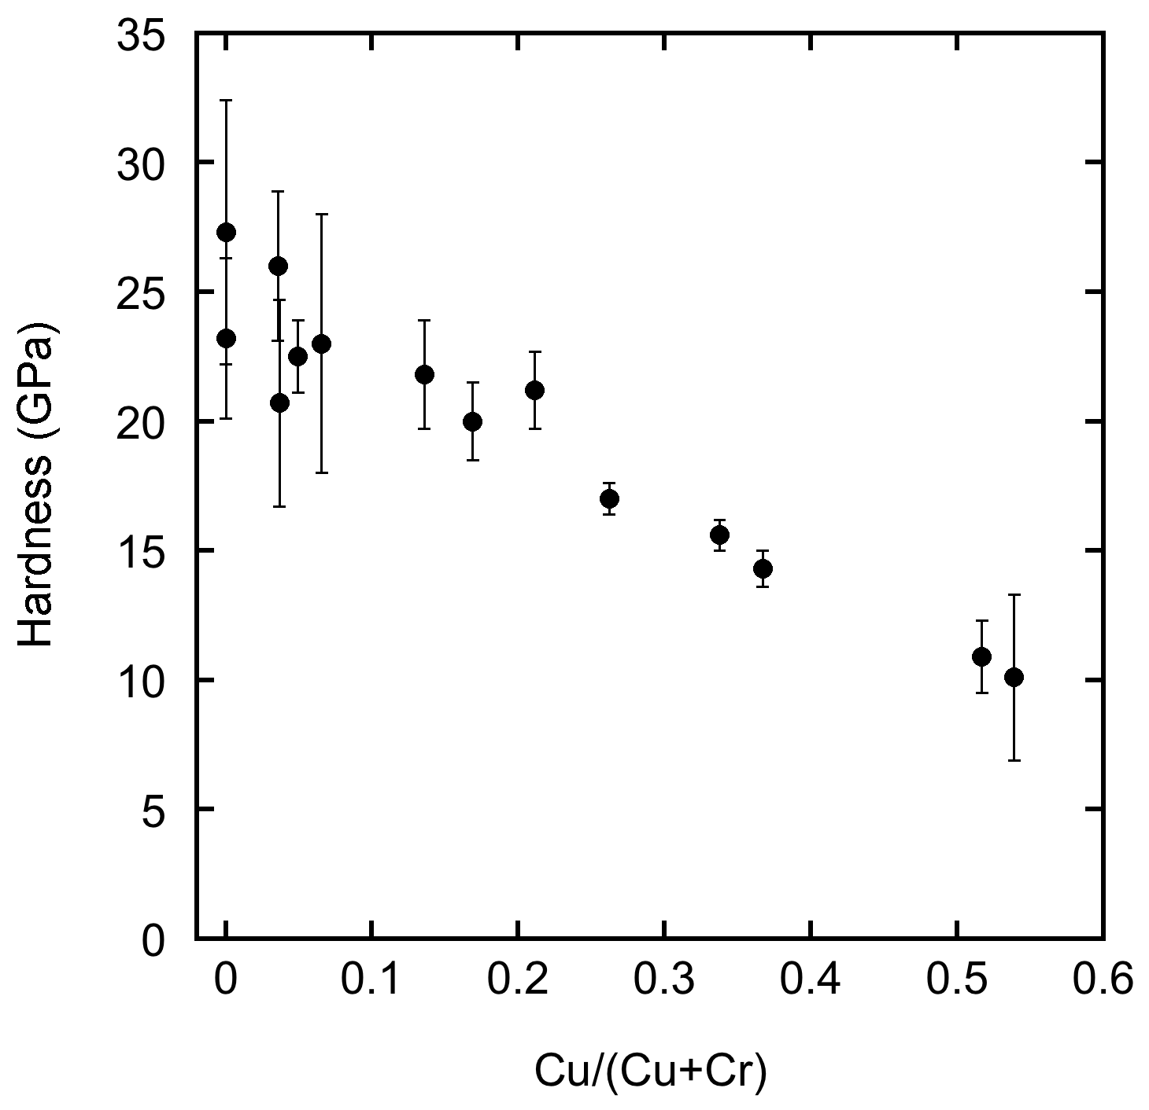

Fig.1: Hardness of Cu-CrN films as function of the atomic fraction copper in
the film.

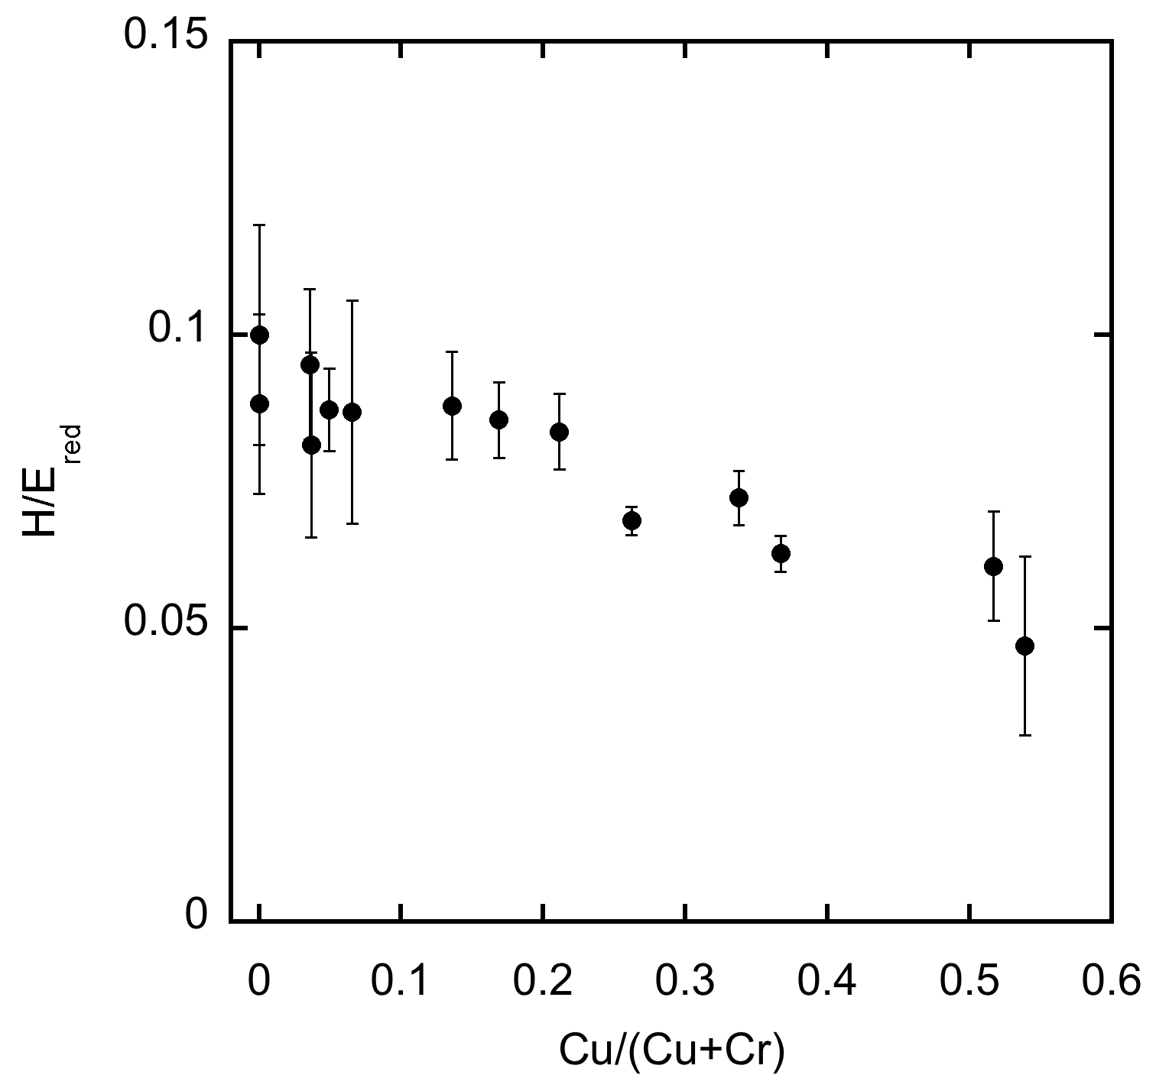

Fig.2: Hardness divided by the reduced modulus for Cu-CrN films as function of the atomic fraction of copper in the film.

We hope that the nanocrystalline material will be superior to the polycrystaline CrN for any of the reasons given above. The scientific challenge is to unravel the reason why the material is superior. This will require an in-depth study of the dependence of the performance on the properties of the material; microstucture, modulus and hardness. During the study into the reason for the beneficial effect of nanocrystallinity we will undoubtedly improve the quality of the layer further.
We did some initial experiments on Cu-CrN to make a connection with the work by Musil. Compared to our state of the art poly-crystalline CrN we did not find an increase in hardness by refining the grainsize but a lowering of the hardness, probably due to plasticity caused by grain boundary sliding [Fig.1]. Since both H and E decrease with increasing copper content one could hope for an increase of H/E with copper content. This is not the case [Fig.2]. Two other findings however are very promising: The roughness of the nanocrystalline material is less than the roughness of the polycrystalline material, giving option 1 a chance. Second, the nanocrystalline films do not contain a stress gradient. While the polycrystalline films always have a fraction of the film under tensile stress [8], the nano-crystalline films can be made in such a way that all of the film is under compressive stress [9]. This feature allows option 2 to be the reason for outperformance of nanocrystalline films. Finally it may be the case that in B-CrN and/or Si-CrN option 3 is the reason for outperformance of nanocrystalline CrN.
An altogether different reason for the outperformance of nanocrystalline coatings over polycrystalline coatings may be a controlled amount of plasticity. Especialy in Cu-CrN one might expect some plasticity at the “soft” grain boundaries. This limited plasticity may prevent catastrophic failure.
In the above presented research plan we discussed the merit of the papers on Cu-CrN in the literature. We are aware of papers on B-CrN [10, 11] and Si-CrN [12, 13], but since at present we have no data to compare these findings to, we restricted ourselves to a discussion on Cu-CrN.

4. Utilization

Coating systems with increased load bearing capacity will allow for higher torque at the same design weigth or for lower weigth at the same design torque. Either way the fuel efficiency will increase and the CO₂ emission will decrease. Frictional losses in car engines are responsible for 1.8% of the CO₂ emission.
The nanocrystalline base layers will be part of a coating system consisting of the hard loadbearing nanocrystalline CrN layer, coverd by a low friction DLC top layer. The performance of the coating system depends critically on the properties of both layers. The DLC toplayer is subject to onging investigations and improvement at Ionbond. In order to introduce the nanocrystalline CrN-DLC coating system in the market we need to validate the complete system. Having a low friction top layer present changes in the load pattern in the underlying base layer. Therefore the development of the coating system requires testing of the complete system, partially produced at TU Delft and partially produced at Ionbond.
Based on our experience sofar with Cu-CrN we estimate that we will need one year for selecting the most promising composition for the three selected nano-crystalline base layer materials, Cu-CrN, B-CrN or Si-CrN together with the settings of the bias voltage and the nitrogen flow. From that moment on the scientific research into the reason for the outperformance of the nano-crystalline material runs in paralel to the testing of the integrated coating system.
With respect to utilization the later years of the projet will be used for testing, first on test specimens and later on customer supplied parts. In the second year we foresee testing of layered systems consiting of nano-crystalline CrN and a DLC top layer. In the third and fourth year we intend to test the coating system on samples provided by customers of Ionbond.
Based on our experience, we are convinced that we can make the nano-crystalline coatings. Provided that indeed nanocrystalline coatings offer an advantage over polycrystalline coatings with respect to load bearing capacity, we do foresee an immediate introduction into the market upon completion of this project.

7. References

1. J.E. Gordon, The new science of strong materials, Penguin books, London, 1968.
2. J.-D. Kamminga, P. van Essen, R. Hoy, G.C.A.M. Janssen, Tribology Letters, 19, 65, (2005).
3. A. Leyland, A. Matthews, Wear, 246, 1, (2000).
4. J. Musil, I. Leipner, M. Kolega, Surface & Coatings Technology, 115, 32, (1999).
5. Jörg Patscheider, MRS Bulletin, March 2003, 181.
6. R. Hoy, W.G. Sloof, G.C.A.M. Janssen, Surface & Coatings Technology, 179, 215, (2004).
7. M.A. Baker et al, J.Vac.Sci.Technol. A23, 423, (2005).
8. G.C.A.M. Janssen, F.D. Tichelaar, C.C.G. Visser, J. Appl. Phys. 100, 093512, (2006).
9. G.C.A.M. Janssen, unpublished result.
10. Rother B, Kappl H, Surface & Coatings Technology, 96, 163, (1997).
11. Yamamoto K, Ito H, Kujime S, Surface & Coatings Technology, 201, 5244, (2007)
12 Mercs D, Bonasso N, Naamane S, et al., Surface & Coatings Technology, 200, 403, (2005).
13. Park IW, Kang DS, Moore JJ, et al., Surface & Coatings Technology, 201, 5223, (2007).

9. Abbreviations and acronyms

AFM Atomic Force Microscope
CO₂ Carbon dioxide
B-CrN Boron doped Chromium nitride
Cu-CrN Copper doped Chromium nitride
CrN Chromium nitride
DLC Diamond Like Carbon
E Young’s modulus
EPMA Electron Probe Micro Analysis
H Hardness
H/E Hardness/Young’s modulus, i.e. maximum elastic strain
Si-CrN Silicon doped Chromium nitride
SEM Scanning Electron Microscopy
TEM Transmission Electron Microscopy
TU Delft Technical University Delft
X-ray diffraction Röntgen diffraction
Improving Fluidized Bed Drying Efficiency: Experiments and Modelling
Dr. J.R. van Ommen (TU Delft, DelftChemTech)

Background. Drying is a very energy-intensive operation used in e.g. food, pharmaceutical and energy industry. It is often carried out using fluidized beds. In the Product & Process Engineering group of DelftChemTech is we research and develop innovative methodologies to considerably increase the efficiency of fluidized beds based on experimental and theoretical / computational work; this research is lead by dr. van Ommen, in cooperation with prof. Coppens. We work together with Dr. Berend van Wachem (Chalmers University of Technology, Sweden), who develops simulations codes for fluidized beds.

Goal. The goal of this project is two-fold:
- To improve the efficiency of fluidized drying processes
- To build a model of a fluidized bed dryer taking into account the process conditions, the drying kinetics of the product, the heat exchange coefficients of inner heat exchangers and the hydrodynamics in the dryer, both for the original situation and the process improvements

Approach. In this project, we will investigate three different ways of improving fluidized bed drying:
- Pulsed fluidization
- Electric fields
- Fractal injection

Figure 1. Three ways of structuring gas-solids fluidized beds: (a) pulsation of the gas flow, (b) imposing an AC electric fields, and (c) fractal injection of gas into the system.
In pulsed fluidization, the gas flow is not entering the bed at a constant flow rate, but an oscillating gas flow is used. We have observed that this leads to the formation of a regular bubble pattern. This can improve the drying process, since throughout the bed the conditions become more uniform. Electric fields can be used to polarize the particles. In a recently delivered PhD thesis, it was shown that the interparticle forces and the bubble size in a fluidized bed can be controlled in this way. In this way, additional degrees of freedom are obtained to optimize the drying process. In the case of fractal injection, part of the gas enters the bed via a tubing system with a fractal, inverted tree-like design, which is submerged in the bed, instead of only via the bottom. This more even distribution of the gas reduces the bubble size and increases the mass transfer. In addition to modifying the reactor configuration, we use advanced process monitoring to follow and optimize the drying process.
Figure 2. Snap-shot of a fluidized bed simulation based on CFD
For a ‘normal’ fluidized bed dryer and for these three modified layouts, experiments will be carried out at the lab-scale to obtain relevant parameters, such as bed voidage, bubble size, and mass and heat transfer coefficients. Optimization of the three control strategies and scale-up effects will be taken into account. Using this input, Computational Fluid Dynamics (CFD, see Fig. 2) models will be developed to describe the different layouts. The model will be validated using both the lab-scale data and commercial data, where available. Finally, the model can be used for further process optimization.

Furfural production from biomass using green solvents

Wiebren de Jong (Process & Energy, TU Delft) & Ruud van Ommen (DelftChemTech, TU Delft)

The world is facing an ever-increasing world energy demand nowadays. This phenomenon is particularly pronounced in quickly developing countries, for example India and China. Moreover, the world economy is still largely being based on fossil fuels at present, resulting in a greenhouse effect due to increasing CO₂-emissions. This makes it very important to find alternative routes to energy carriers and chemicals. The first-generation bio-refinery often aims at the production of bio-ethanol. However, this product has a relatively low economical value as a bulk chemical. In this project we aim at the development of a novel bio-refinery process for the production of liquid transportations fuels via the coupled production of syngas and the platform chemical furfural.

The current worldwide production of furfural is year about 150 kton (Ullman, 202). However, in future it will probably be applied as the feedstock for THF, durable wood production, nylon production, and several other chemicals. Therefore, it is expected that the production will increase with a factor of more than 10 in the coming 15 years.

Currently, the relatively high cost price (~ 1000 Euro/ton) makes it impossible to compete with traditional chemistry. The main reasons are:
- The low yield of the current production technology (30-35%)
- The large amount of steam needed (20 times the amount of furfural)
With the existing batch technology, these factors cannot be significantly improved. Therefore, this project aims at developing a novel, continuous reactor which is fed with biomass rest streams. In this reactor, hemi-cellulose will be converted into C5-sugars, which are subsequently converted into furfural. By carrying out these processes in an ionic liquid or a different green solvent (e.g. hyperbranched polymers), it is possible to obtain a much higher selectivity than with the conventional process. Moreover, it is possible to combine reaction and separation in a more efficient way. An additional advantage is that the by-product of the primary conversion step (the lingo-cellulose, which is 2/3 of the fuel) can be added to an oxygen/steam gasifier in a rather simple way. In this way, hydrogen-rich fuel gas can be produced which can be deployed in the production in green transportation fuels (e.g., Fischer Tropsch Diesel, methanol, DME etc.).

The project work will consist of a process design regarding the whole refinery process, and experimental and modelling work concerning the new reactor concept.

J. Meier, S. Dubail, R. Flückiger, D. Fischer, H. Keppner, A. Shah, in Proceedings of the 1st World Conference on Photovoltaic Energy Conversion, Hawai (1994), p. 409-412.
J. Meier, S. Dubail, J. Cuperus, U. Kroll, R. Platz, P. Torres, J.A. Anna Selvan, P. Pernet, N. Beck, N. Pellaton Vaucher, Ch. Hof, D. Fischer, H. Keppner, A. Shah, Recent progress in micromorph solar cells, J. Non-Cryst. Solids 227-230 1250-1256 (1998).
K. Yamamoto, M. Yoshimi, Y. Tawada, Y. Okamoto, A. Nakajima, Thin film Si solar cell fabricated at low temperature, J. Non-Cryst. Solids 266-269 1082-1087 (2000).

